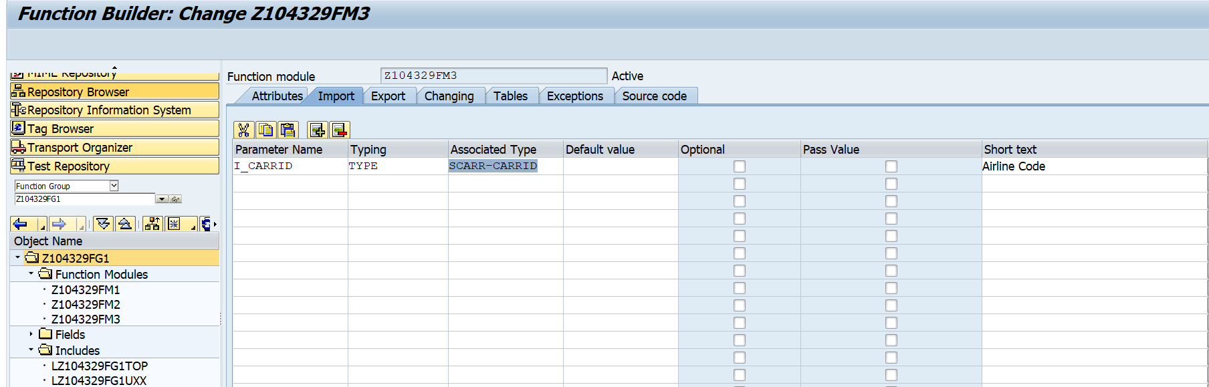

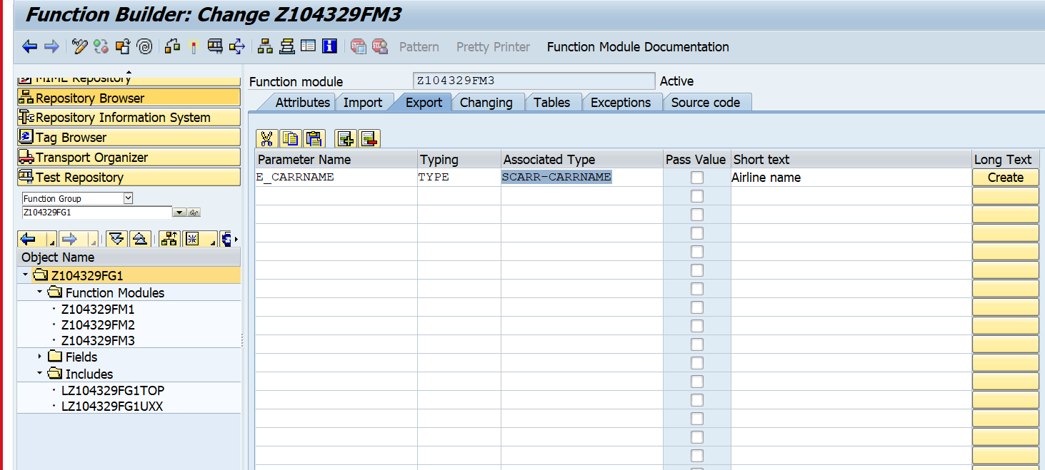

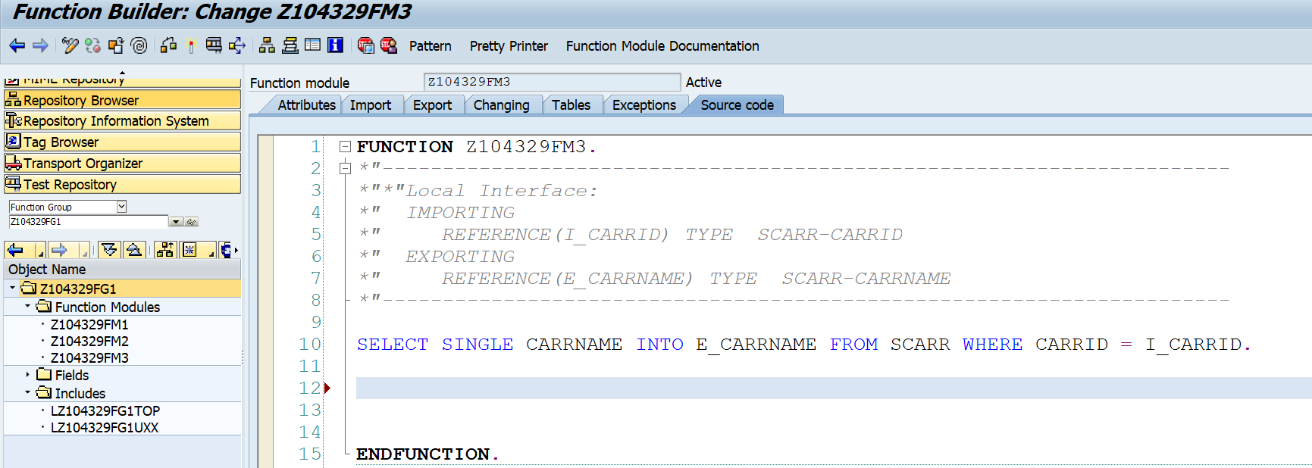

REPORT Z.  
PARAMETERS PCARRID TYPE SCARR-CARRID.  
DATA L_CARRNAME TYPE SCARR-CARRNAME.  
  
CALL FUNCTION 'Z104329FM3'  
  EXPORTING  
    I_CARRID         =  PCARRID  
 IMPORTING  
   E_CARRNAME       =   L_CARRNAME.  
  
  
 WRITE L_CARRNAME.

Copy above Function Module to another Function Module.

Create table type in SE11.

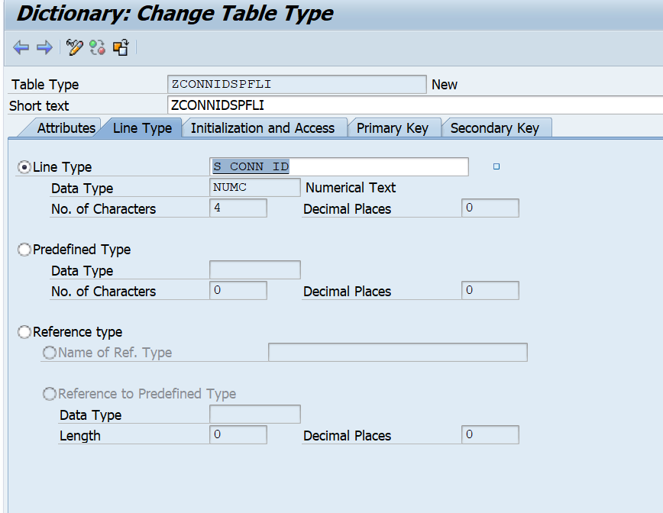

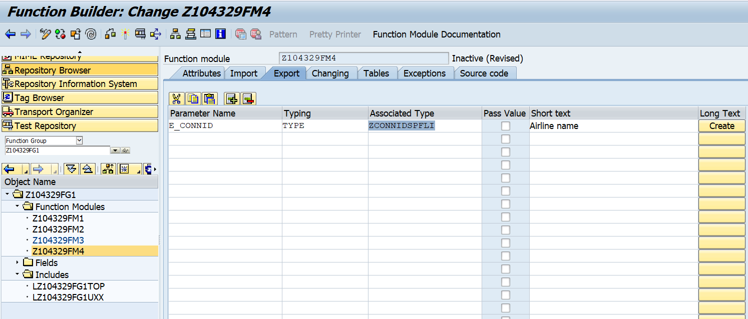

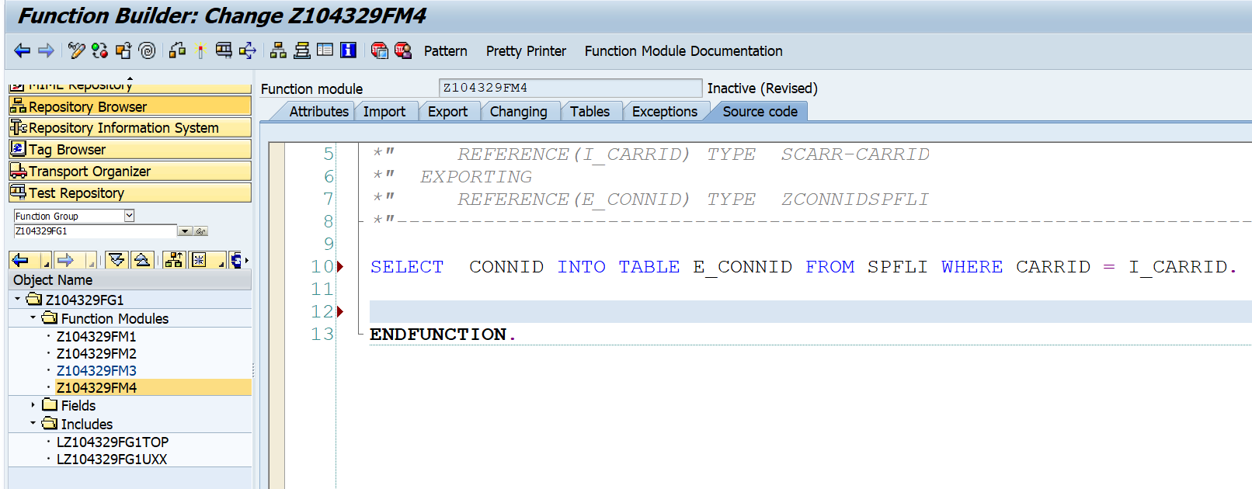

Execute the above FM.

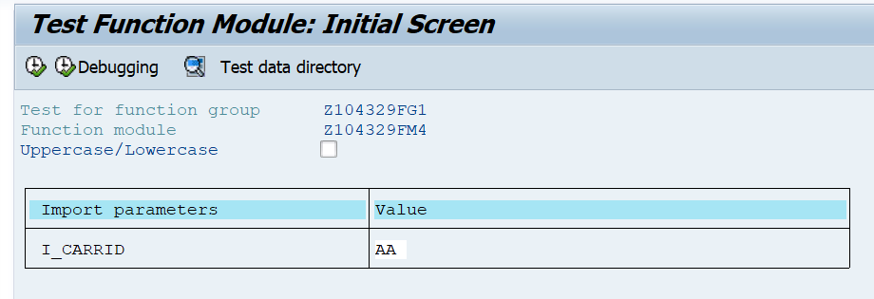

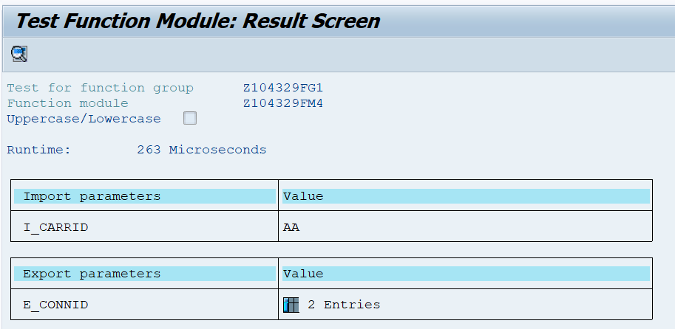

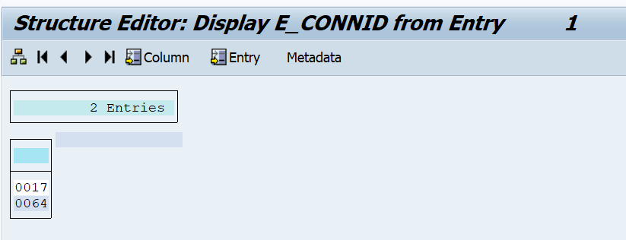

REPORT Z.  
PARAMETERS PCARRID TYPE SCARR-CARRID.  
*DATA L_CONNID TYPE TABLE OF  SPLFLI-CONNID.  
*OR  
DATA L_CONNID TYPE ZCONNIDSPFLI.  
  
CALL FUNCTION 'Z104329FM4'  
  EXPORTING  
    I_CARRID       =  PCARRID  
IMPORTING  
   E_CONNID       =  L_CONNID.  
  
CL_DEMO_OUTPUT=>DISPLAY_DATA( L_CONNID ).

“CL_DEMO_OUTPUT is a standard class.